This write-up walks through the steps required to output Annual and Peak Growth Factors for the ERTAC EGU model.
MARAMA Prepared a Microsoft ACCESS Database to develop annual and peak growth factor tables for any year out to 2030. You can access the database through the ERTAC FTP site:
ftp.marama.org
Username: ERTACmembers
Password: Sharesite
The current version of the MS ACCESS Database is “ERTAC_GF_Table_Join_042611.accdb”
Step 1
Open the ERTAC MS ACCESS database
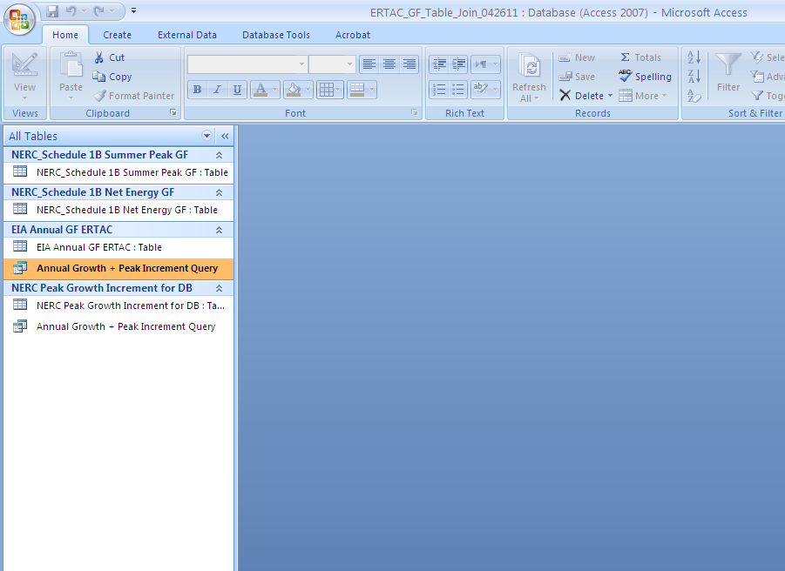

Step 2
Navigate to the query table “Annual Growth + Peak Increment Query”. Right click on the table name and select “Design View” as shown in the image below.
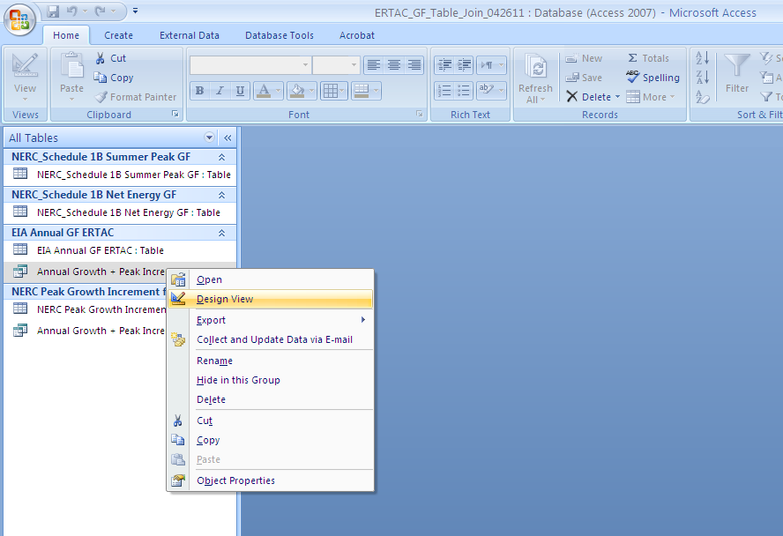

Step 3
Change the year of the EIA Annual Growth Factor. The query is set up to prepare a growth factor table for 2020, but it can be easily changed to any year out to 2030. Erase “2020” and manually type the desired year in the “Field” row of the 5th column. The correct location is show in the image below.
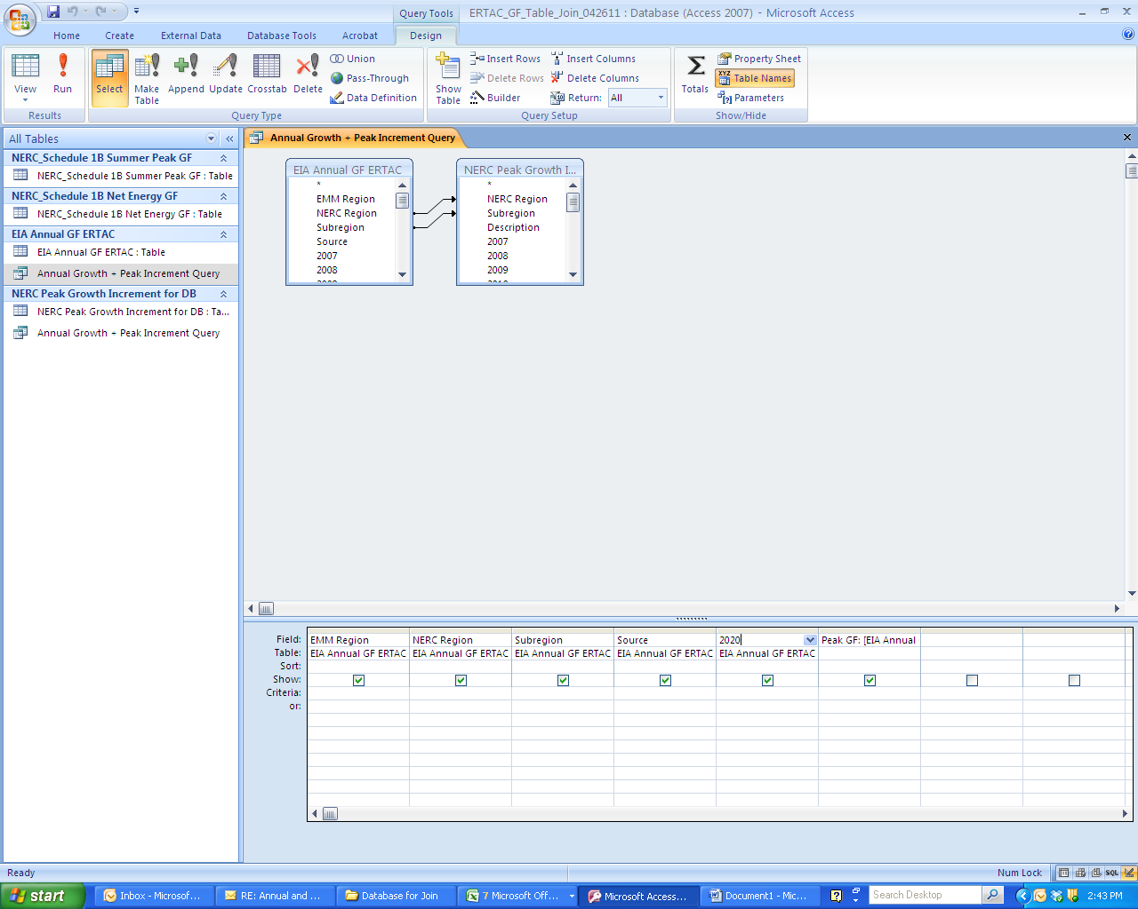

Step 4
Change the year of the peak growth factor. An expression was built into the query to add the peak increment to the annual growth factor. The expression looks like this:
Peak GF: [EIA Annual GF ERTAC]![2020]+[NERC Peak Growth Increment for DB]![2020]
All you need to do is manually enter the desired year into the expression. For example, if you wanted to develop growth factors for 2025, the expression would look like this:
Peak GF: [EIA Annual GF ERTAC]![2025]+[NERC Peak Growth Increment for DB]![2025]
The year you enter into the expression should match the year you entered in the 5th column (Step 3). The image below points to where the changes are required.

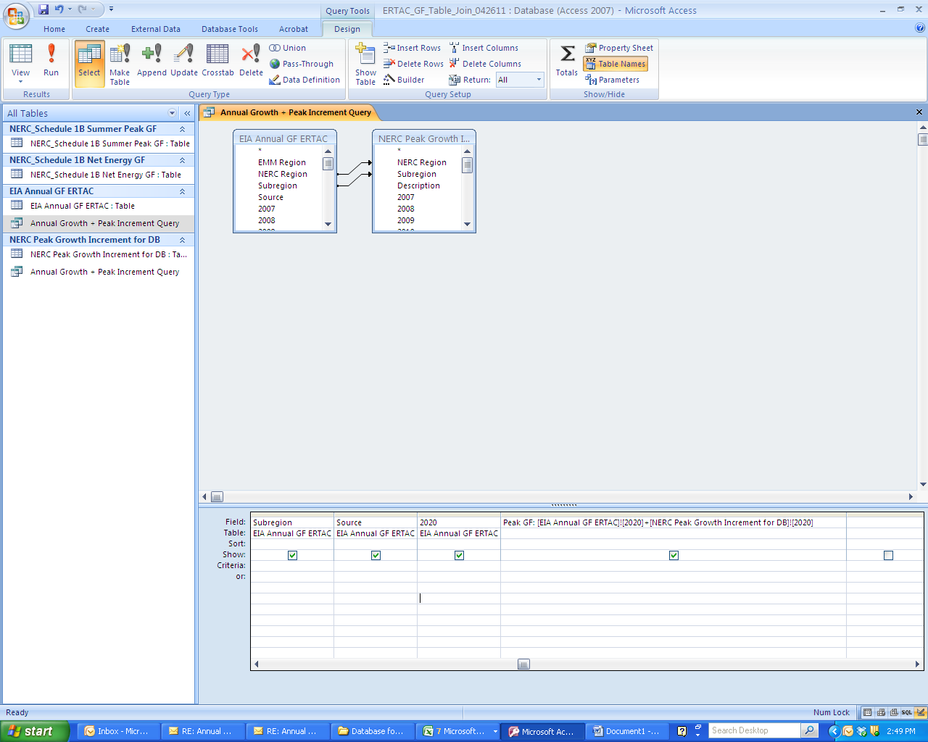
Step 5
Hit “Run”, which should produce a table of annual and peak growth factors for the desired year. Save the query and right click on the query name and “Export to Excel” if desired.
